
Solution Outline



Status : Draft
Version : 0.1
Last modified : 12 september 2014

Document details

Contributors
Name | Role | Organization

Bram Havers | Architect | IBM

Index

1 Introduction 5
1.1 About the Poseidon project 5
1.2 Objective 6
1.3 Audience 7
1.4 Scope 7
1.5 Approach 7
2 Vision & Roadmap 8
2.1 Introduction 8
2.2 Problem Statement 8
2.3 Position Statement of Poseidon 8
2.4 Architecture Overview 8
2.5 Architecture Principles 10
2.6 Stakeholder Summary 10
2.7 System Context Diagram 11
2.8 Needs and Features 12
2.9 Requirements 12
2.10 Roadmap 13
3 Solution Architecture Iteration 1 – Poseidon@School 14
3.1 Introduction 14
3.2 Objectives 15
3.3 Deliverables 15
3.4 Architectural decisions 16
3.5 Use case Model 16
3.6 Mapping use case - tutorial 17
3.7 Functional Components derived from use cases 17
3.8 Tutorials 18
3.9 Operational Model 18
4 Solution Architecture Iteration 2 – Poseidon@Farm 20
4.1 Introduction 20
4.2 Scope 21
4.3 Objectives 21
4.4 Deliverables 21
4.5 Architectural decisions 21
4.6 Use case Model 21
4.7 Functional Components derived from use cases 21
5 Solution Outline – Final 22
5.1 Component Model - logical 22
5.2 Component Model - specified 22
5.3 IBM Internet of Things cloud 23
5.4 High Level Operational Model 23
5.5 Architectural Decisions 23
5.6 Assumptions 23

Introduction

About the Poseidon project
Poseidon aims to reduce the overuse of fresh water in the world. Did you know that the average cup of coffee averages 140 L of water? Or that a cotton shirt is 3100 L of water? We call this "Virtual Water", see poster in appendix A.

Most of the Water Footprint of the EU (that is, our total use of water), is in countries outside the EU. Most prominently, in Central Asia, which suffer under tremendous water stress and are depleting their natural sources fast. The most striking example is the Aral Sea, which is drying out in a rapid pace, leaving nothing but dry desert on the land which was once ocean
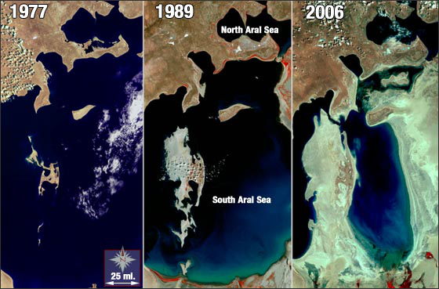
Figure 1 Aral sea drying out

The Poseidon project aims to make a change in all of this by creating awareness through education and marketing and providing assistance by developing low cost open source devices connected to an IBM Bluemix platform to assist local farmers in more efficient irrigation. We call this precision agriculture.

The project is a voluntary initiative that creates actionable insight for farmers to reduce water usage. The Poseidon solution will monitor the environment and collect the data in the cloud where it will be available for scientist to develop new insights. The solution will be easy to use through mobile devices. Scientists and application developers can easily extend the solution with new functionality because the data will be available as Open Data, and will be accessible by systems through API´s.
The solution will be based on the IBM Bluemix cloud platform to scale up as the need for data and computational resources increases.

The Poseidon project is the first project of the Dutch Courage foundation to educate students at 15 universities throughout Asia about the use of this technology. A part of the team will be driving through Asia (Russia, Mongolia, Kazakhstan, Uzbekistan and other countries) to provide this education. The objective is to stimulate students to join the community and extend the Poseidon platform.
In the process of this trip, we expect to lecture at some 15 universities in the region, challenging them to work with us on this global problem, if you would like to spread the word, feel free to use our education material and/or messaging. Together we can change the world!
During our trip we will be blogging and communicating through the following websites:

More information on:
- The Dutch Courage, the charity hosting the project;
- The Poseidon Community for collaboration
(ask Wing for access)
- About Poseidon brochure

Objective
The objective of the Dutch Courage foundation is to reduce the water footprint through education. The Poseidon Project enables this objective by providing a water monitoring solution.
Currently we are focused on the first iteration of the project until the end of 2014. The objective for the first iteration is focused on education and community building. Later iterations increasingly work towards a production ready solution for environment monitoring and decision making.

First iteration objectives
The objective of the first iteration of Poseidon is to:
- Develop a water monitoring solution for educational purposes.
- Deliver education material for building the solution
- Build and support a community of cross discipline enthusiasts (scientists, hydrologists, agriculture experts, application developers, hardware experts, etc)
This iteration delivers a starter solution for experimentation and stimulates others to extend it, in order to facilitate the creation of ‘production-ready’ products.

Long-term objectives
On the long-term the Poseidon objective is to
- Offer a platform to host and distribute Climate Change related data (as Open Data).
- Offer a platform that can easily be extended with technologies known by the student and science community
- Grow re-useable Bluemix services (like specific models) that will speed up the development of new science.

Audience
This document is written to understand the technical aspects of the Poseidon solution. It is relevant for everybody that has an interest in Poseidon and would like to understand the architecture.

Scope
This document defines the architecture and technical design for the Poseidon project.

Approach
For a structured and iterative approach the project follows the Eclipse Open Unified process method. See the Eclipse OpenUP website for a background of this method. Paragraphs in this document are based on the work products from that method.

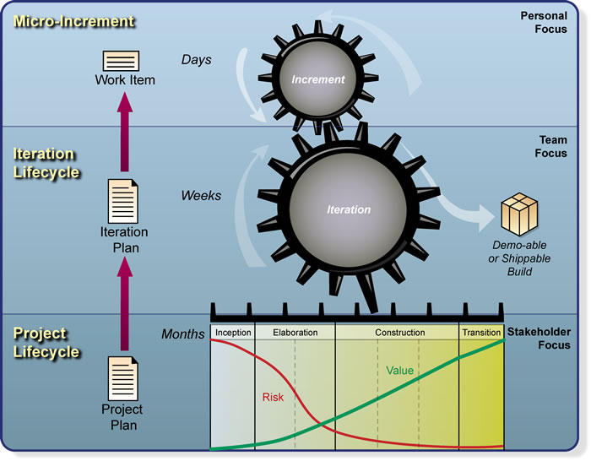
Figure 2 OpenUP layers: micro-increments, iteration lifecycle and project lifecycle

Vision & Roadmap

Introduction
The vision paragraph defines the end state of the envisioned Poseidon solution. This vision will be realized in various iterations. The solution will evolve through these iterations to realize the vision.

Problem Statement
The problem statement summarizes the problem being solved by this project.

The problem of | Water scarcity through a changing climate and misuse of natural resources
affects | Agriculture (farmers)
the impact of which is | Reduce effectiveness of agriculture, ultimately leading to conflicts
a successful solution would be | Provide actionable advice to more efficiently use the available (water) resources based on factual data.

Position Statement of Poseidon
This position statements provide an overall statement summarizing, at the highest level, the unique position the product intends to fill in the marketplace.

For | Agriculture (farmers)
Who | Need better advise on their water usage
The (product name) | Poseidon platform
That | Provides water usage advise and freely accessible factual data about the environment
Unlike | The current lack of solutions and availability of data in the current situation
Our product | will be an easy entry solutions for farmers, that the global community of scientists can extend to build a better world.

Architecture Overview
The Poseidon Project aim to provide two types of solution approaches:
- a ready-made product, including a plant monitoring device, a platform to store and distribute sensor data and the applications to analyse the data, share it on social platforms and mobile devices
- tutorials to extend the Poseidon solution by becoming member of the team, or build their own solutions.

The code, data and design documents and tutorials for the ready-made product are publicly available (open source, Open Data). The Poseidon Project wants to stimulate free and open use to maximize experimentation. Everybody can join the project and extend the solution, or take the code and examples and build their own monitoring solution that change the world.

Architecture overview below highlights the key aspects of the Poseidon Architecture.

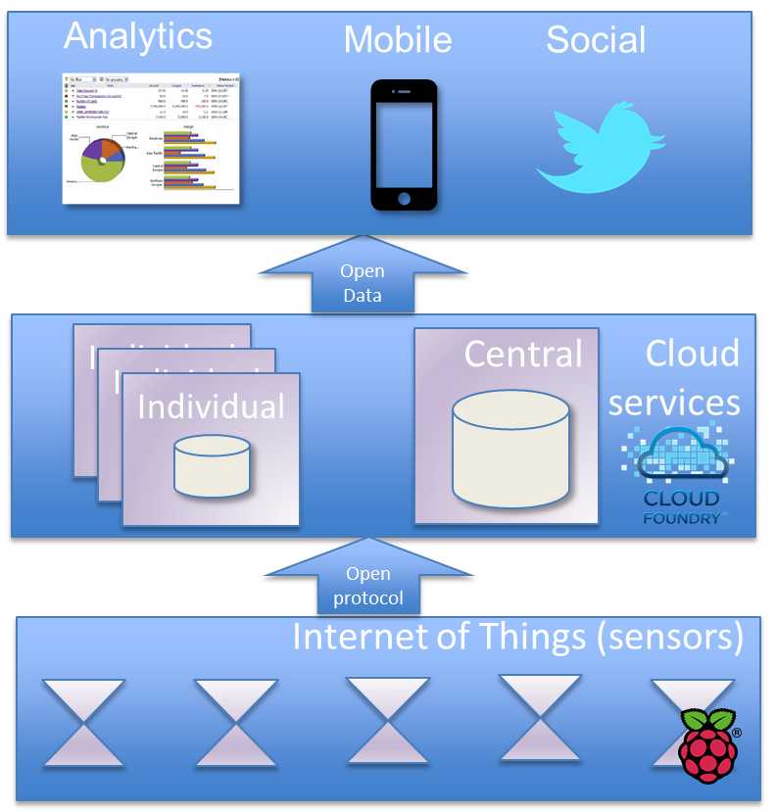
Figure 3 Architecture Overview Poseidon Project

The Internet of Things layers holds the sensors. The Poseidon Project provides an example implementation of a in-house plant monitoring (sensor) solution based on the Raspberry Pi. Other monitoring solutions are supported as well. The sensors will send their data by an open, and sensor data optimized, protocol to the a cloud environment.

The cloud environment holds the central data store and data distribution mechanism. The Poseidon Project will maintain one central cloud environment to continuously capture and distribute the sensor data. This design and tutorial to build this platform are publicly available so users can also start their own Indivual cloud environment to experiment and build new innovations.

To show the potential the Poseidon Project will provide a mobile app that visualizes the monitoring data. The data will be analyzed for triggers (time to water the plant). A forecasting model will analyze the data and provide a planning for watering the plant, a start for precision agriculture.
To stimulate good caring of your plant, the watering times will be made publicly available on social media.

Architecture Principles
In order to reach the objective of the Poseidon project, the solution will have the following characteristics:
- Easy entrance
Poseidon will make it easy for anybody to join the project, this is reflected in all aspects, like description of tutorials, technology choices and design decisions.
- Stimulate experimentation
We want to excite and provide as many people to try this hands-on and submit ideas, design concepts or code.
- Open architecture
Design and code will be available so people can understand and extend the technology.
- Low cost
We want to keep the barrier for entrance low, and so the cost for experimenting.

Stakeholder Summary

Name | Description | Responsibilities
[Name the stakeholder type.] | [Briefly describe the stakeholder.] | [Summarize the stakeholder’s key responsibilities with regard to the system being developed; that is, their interest as a stakeholder. For example, this stakeholder:  ensures that the system will be maintainable  ensures that there will be a market demand for the product’s features  monitors the project’s progress  approves funding  and so forth]

System Context Diagram
The System Context Diagram describes the solution as a blackbox and highlights the external actors (systems and people) that interact with the solution, see figure below.

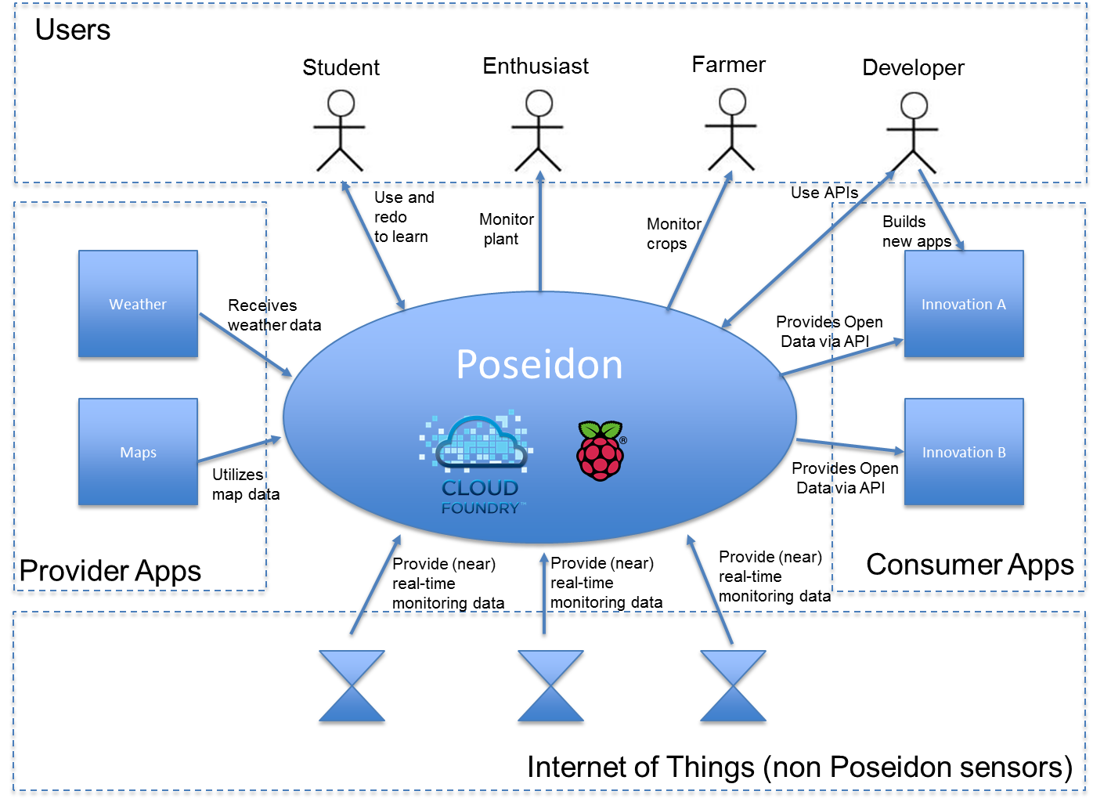
Figure 4 System Context Diagram Poseidon Project

The Poseidon solution is described at the Architecture Overview paragraph above. Here we will describe the actors that interact with the Poseidon solution

Users
 | Student | Use the provided tutorials to learn about the technology for the end-to-end flow from sensor to application. We hope we stimulate the student to become an developer and create innovative solutions
 | Enthusiast | Mainly home users who like the idea of Poseidon. They will follow the instruction to setup the monitoring solution and monitor their plant. They are non-technical. Poseidon stimulates them to submit ideas and, spread the word and take initiative to improve the world
 | Farmer | Will use Poseidon to monitor their crops and receive precision agriculture forecast that improves their farming results while reducing their footprint.
 | Developer | Extends the Poseidon platform in any way. This could be enhancing its functionality or producing better results. A developer could also use the concepts of Poseidon and independently build their own solution. Either way is fine, if it creates a better world.
Internet of Things (Non Poseidon sensor)
 | Sensors | All monitoring solutions that are not provided by the Poseidon project. As long as they use the specified protocol and format, their data will be included.
Providing apps
 | Weather | This is an example, any system could be providing data that is interesting to merge with the monitoring data. In this example, weather data is integrated in Poseidon to support the forecasting model to find the best moment for precision agricultate.
 | Maps | Another example. A mapping service will provide graphical maps to visualize position of crops or sensors
Consumer apps
 | Innovation A | We have no clue yet. Anybody with a great idea can use the data inside the central Poseidon instance for their new innovation. We hope to stimulate others to come up with new and great application that improve the world.

Needs and Features
This paragraph provides general feature needs (capabilities) that need to be provided by the solution.

Need | Features
Monitoring device | Monitor the local weather  Monitor the environment (soil, water flow)
Data storage and access infrastructure | Store data from monitoring solution  Make data available for others to develop insight and applications on.
Water usages advise application | The advise should be available on a mobile devices

Requirements
At a high level this paragraph lists the applicable standards, hardware, or platform requirements; performance requirements; and environmental requirements.

Requirement | Description
Open Data | Data must be available as Open Data (no limitation on usage) to accelerate science development that can lead to new insights and advise
Scalable | Start small, but be able to scale solution when data and computational need increases
Usability for end user | Easy for end-users to use
Usability for developer | Easy for scientist and application developers to use
Open Interfaces | The platform is open for everybody through Open API´s

Roadmap
We need a couple of iterations to realize the vision. Because the solution is based on voluntairy effort we would like to make each iteration a relative small amount of work with tangible objectives that can be realized in a short amount of time.
We will add complexity as we go along.

Challenges for the eacht iteration

Iteration 1 (end of 2014):
- Get the basic solution end to end (from sensor to advise) working in a simplified solution
- Deliver education material on the end to end solution, so others can extend the Poseidon platform.

Iteration 2 (half 2015):
- Connect more monitoring devices and sensors
- Improve functionality of advise applications, and publish a first version in app stores for general beta testing.
- Scale the platform to contain sensor data
- Improve the scientific models to provide better advise

Iteration 3 (end of 2015):
- Improve usability and visual appearance of apps, they should now become ‘production’ ready.
- The platform is managed, new versions will not disrupt earlier versions and availability is guaranteed.

Other iterations might be needed to implement the vision, but will be defined when there is a clearer view on requirements and direction.

Solution Architecture Iteration 1 – Poseidon@School

Introduction
In the first iteration of the Poseidon project we will develop a solution and education material for monitoring the soil moisture of plants. When the soil is to dry, it will send a twitter message and notification to the plants owners mobile. The data will be stored in a cloud platform and made available on a mobile phone. This data will be analyzed by a model developed by universities that will notify the user in advance that watering is needed. As these models take time to do the calculations, the education material will end with an example how to scale up computational resources in the cloud at peak moments.

The scenarios above will be described in detail in use cases. The use cases will be analyzed for functionality and data structures. This will lead to a component model that defines the a functional components that need to be implemented. The setup, configuration and development of these components is the foundation of the tutorials that will be delivered at the end of this iteration. In the tutorial we will show step by step how to build such a solution.
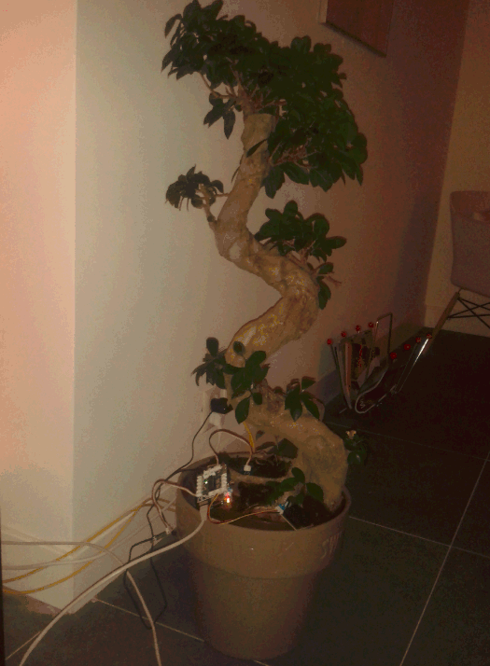
Figure 5 Monitoring and twittering plant

Objectives
The objective for this iteration it is to:
- Deliver a monitoring device based on Raspberry Pi.
- Deliver a central platform to store sensor data and send out tweets based on configurable threshold values.
- Setup the development environment for developing applications and sharing the source code.
- Delivering three tutorials (on IBM developerWorks) that helps others understand the technology and extend the Poseidon solution.

Deliverables
The deliverables are three tutorials

# | Name | Description | Theme
1 | Soil moisture monitoring stations | A low cost soil moister solution for plants at home. This can later be extrapolated to industrial soil moister sensors for agriculture.  The monitoring solution will capture and cache monitoring data and sends it periodically to a central data store.  The data store will publish data of a variety of sensors to social media for interested listeners. | Internet of Things,  Social
2 | Mobile visualization of data and notification | Data will be stored in the central platform  An Open API will be available to provide data, and to acquire data from the data store  A device-independent app visualizes the real-time data  An alarm is set on the data that will notify the user when it is watering time for their plant. | Mobile
3 | Scaling computational needs | A simple analytical model will forecast what is the optimal time is for watering the plant  To speed up the time of forecasting reports, the solution will be scaled to 10 cloud instances. This will decrease the computational time for crisis situations. | Analytics & Cloud elasticity

Architectural decisions
To realize the objective we have made the following decisions
- The monitoring prototype will use Raspberry Pi components.
This is a low-cost and easy to start platform for monitoring that is designed for educational purposes and therefore fits very well with the projects objectives.
- The cloud environment to be used will be IBM Bluemix for the central place to store and distribute data.
- The development environment will be IBM DevOps for central storage of source code. The development environment will be a local installation of Eclipse
TBD: check if we can use online development IDE.

Use case Model
The use cases describe the functionality needed by the end user and how the user and other system will interaction with the future solution. Each use case provides a step by step description of the working of the envisioned solution.

UC1 – User: setup monitoring device

List of components to buy
Setup Pi base, follow: http://www.raspberrypi.org/introducing-noobs/

GrovePi http://www.dexterindustries.com/GrovePi/get-started-with-the-grovepi/

Soil moisture sensor: http://computers.tutsplus.com/tutorials/build-a-raspberry-pi-moisture-sensor-to-monitor-your-plants--mac-52875

Install mqtt libs
sudo apt-get install mosquito
sudo pip install paho-mqtt
sudo apt-get install python3-mosquitto

UC1 – Developer: Set-up soil moisture monitoring device

UC2 – Developer: Setup development environment

UC3 – Developer: Configure publication of monitoring data

UC4 – Developer: Tweet soil status data

UC5 – Deverloper: Central data storage and distribution

UC6 – End user: Check soil status on mobile device

UC7 - End user: Check watering alarm to mobile device

UC8 – End user: Check watering forecast

UC9 – Administrator: Scale watering forecast service

Mapping use case - tutorial

Functional Components derived from use cases
Functionality identified in the use cases will be grouped in Functional Components. These components will need to be developed. The process description of this development activity is the red line for the tutorials

The following Functional Components have been identified

Component | Description
Weather station
Sensor data acquisition
Sensor data storage

Publishing of Open Data
Mobile access to data
Forecasting

Tutorials
This paragraph will the tutorials and which components will be developed.

TBD: include matrix with tutorials / functional components, something like this.

 | Comp 1 | Comp 2 | Comp 3 | Comp 4 | Comp 5 | Comp 6
Tutorial 1 | Build |  | Build | Build
Tutorial 2 |  | Build |  | Upgrade | Build
Tutorial 3 |  |  | Upgrade |  |  | Build

Tutorial 1 Weather station data acquisition and publishing
The tutorial describes the end to end process from setting up a low cost weather station using off the shelve components. To submitting that data to Bluemix and publishing the data on social media.

The learning objective is to understand the end to end working of the solution

TBD: describe steps.

Mobile visualization of data
TBD

Tutorial 3 Running and scaling an forecasting model in the cloud
TBD

Operational Model
The Poseidon solution has two main components
- Sensor device (decentralized)
- Central data store

Sensor device
The Poseidon-Pi is an open source computer (Raspberry Pi), with 3 essential sensors: Barometric Pressure, Temperature and Soil Moisture. Each of these sensors will send readings into an informix database (through NodeRed / MQTT).

TBD: List of components + where to order + price.

Cloud platform

The Poseidon Project will run on the IBM Bluemix environment.
Bluemix is a Platform as a Service environment. It provides the hardware, networking components, Operating System and application support services.
With the application support services new applications can be build.

We will use the following Bluemix services
- Internet of Things boilerplate.
This boilerplate (template) is a predefined set of services: a NodeJS environment, Cloudant noSql database,
- Mobile notifications
- …

We will use services that are free of charge and any student can use. The students will instantiate their own Bluemix environment.

A central environment will be available that logs all sensor data and visualizes it. This environment main purpose is for to be a starting point for the next iteration.

Describe capabilities of Cloud Foundry, maybe use: http://blog.altoros.com/paas-cloud-foundry-foundation.html

Solution Architecture Iteration 2 – Poseidon@Farm

Introduction

Notes from mail RJ 28-08-14 15:38
To be integrated in this document

The real-life case for Poseidon envisions two or three testfields with real sensors, assume 50x3 measurement points per field. The overall architecture will be similar to the above, except we will add weather data (wunderground) and a NodeJS instance to visualise the data and load the data from the Wunderground apis. Moreover, the models developed will be more intense.

Data assumptions:
50x6x3 = 450 measurements per 15 mins, will be around 86400 sensor readings per day, i.e. 31535000 per year. Not sure how these numeric data would end up in Informix, but I assume it wouldn't be too large (around 3 gb).

Next to this, we would enrich with overall data from Wunderground, adding hourly weather predictions from a range of weatherstations. This would include precipation (one wouldn't irrigate when rain is expected), humidity, wind, etc. We are still desiging the overall data flow for this. Assume it will be similar in size (regional prediction) to the data from the sensors, making the yearly requirement some 6GB in storage.

Moreover, we would store data on administration, geolocation, etc.; assume we will reach a max of 10GB in storage in the first year (so untill end 2015).

Mobile App
The app for farmers will get realtime push messages when irrigation is deemed necessary by the system. Similarly to the School module, we will first start with treshold based triggers and gradually move towards analytics and planning.
We assume some 20 app users (students, farmer, etc) per farm, totalling some 60 users.

Analytics
We would run spatio-temporal analytics upon the informix timeseries, if I am not mistaken there is a service for that? The model would be computationally intensive I suppose, not sure how to calculate this towards GB/Hrs.

Web
The complete project will be visualised through a NodeJS website, where data can be visualised and realtime data from farms can be observed by the general public. Assume we have a nodeJS instance running and we would receive some 1000 visitors daily, I guess we would need to scale?

Scope

Objectives

Deliverables

Architectural decisions

Use case Model

UC1 – User: setup monitoring device

Functional Components derived from use cases
Functionality identified in the use cases will be grouped in Functional Components. These components will need to be developed. The process description of this development activity is the red line for the tutorials

The following Functional Components have been identified

Component | Description
Weather station
Sensor data acquisition
Sensor data storage

Publishing of Open Data
Mobile access to data
Forecasting

Solution Outline – Final
TBD: Deze paragraag herzien. Deels onder visie onderbrengen (of onder Final Iteration) en deel onder iteratie 1.

Component Model - logical
The Functional Components have been grouped:

Functional Component | Description

Description of the functional components

Functional Component | Description

Component Model - specified

Figure 6 Software mapping on Component Model

This paragraph provides a short introduction to the products used and the concepts behind it. Must provide the reading in one page an understanding and links to further detail.

Template for paragraphs:
- Korte (paragraaf) beschrijving van component
- Link naar video What is
- Link naar video How to

Bluemix

What is Bluemix, what is PaaS?
What are boilertemplates?
What are services?
What are application?

What is CloudFoundry

Bluemix boiler template IoT

Bluemix

Sensor devices

What is Raspberry Pi
Which sensors did we select

IBM Internet of Things cloud
What is IoT Cloud and how integrated with Bluemix
What is MQTT?

DevOps

High Level Operational Model

Architectural Decisions
- Historical operational data (7 years) is maintained in IOC data store.
Integration will be build to TACCS. Would have been no problem to do it the other way around.

Assumptions

Appendix
